Medical and Scientific Communication Competition
Thank you for your interest in our competition!
With the rapid advancements in medical and scientific research, effective communication of ideas has become increasingly important to inform and educate a variety of audiences. This competition is designed to celebrate and promote the skilful and effective communication of medical and scientific information. Through the competition, we hope to inspire and encourage upcoming people like you to explore the potential of a career in medical writing, ultimately contributing to advancing medical and scientific knowledge for the benefit of all.
This competition is also an opportunity for you to win a half-day Medical and Scientific Communications Masterclass at the VMLY&R office in Manchester and cash prizes.
Brief: Communicating the findings from a study of a continuous glucose monitoring device to a professional and lay audience
Task 1: Slides for a professional audience
The pharmaceutical industry frequently partners with clinical and academic experts to present data at scientific congresses. As medical writers, we are often commissioned to help speakers prepare their slides. For this competition, assume that you have been contracted by one of the sponsors of the following study to create slides for a presentation at an upcoming diabetes conference.
Link to paper: https://jamanetwork.com/journals/jama/fullarticle/2598770
- Prepare up to 10 slides for the speakers to present at an upcoming diabetes conference to a healthcare professional audience.
- Communicate the effect of a continuous glucose monitoring (CGM) device (DEXCOM G6) on diabetes management.
- Your slide deck should include the following:
  - Introduction
  - Justification for this study
  - Methods
  - Results
  - Clinical implications of the results
- Consider the visual layout of the information
Note: While the majority of your presentation should be focused on the paper provided, consider what other information may be relevant to include.
Task 2: Social media infographics for a patient audience
Social media is playing a bigger and bigger role in medical communications. As well as reaching healthcare professionals, pharmaceutical companies also have an important role in raising awareness among patients and the public about advancements in science and health. For this task, assume that you have been commissioned by the owners of the CGM device to produce a series of three infographics to be posted on their twitter page.
- Create 3 infographics using PowerPoint or similar software aimed at a patient audience in an infographic style. The infographics should cover:
  - What is a continuous glucose monitoring device?
  - Who are CGMs recommended for?
  - What are the benefits of using a CGM device?
- Example infographics are shown on the next page. We do not expect you to produce infographics to this level, though do consider the layout and use of graphic elements in your submission
Tip: Remember that it is illegal to market pharmaceutical products (including medical devices) to the public in the UK. When creating your slides, carefully consider what would be appropriate to say in this context – as a general rule, you should talk about CGMs as a technology rather than focusing on a particular product.

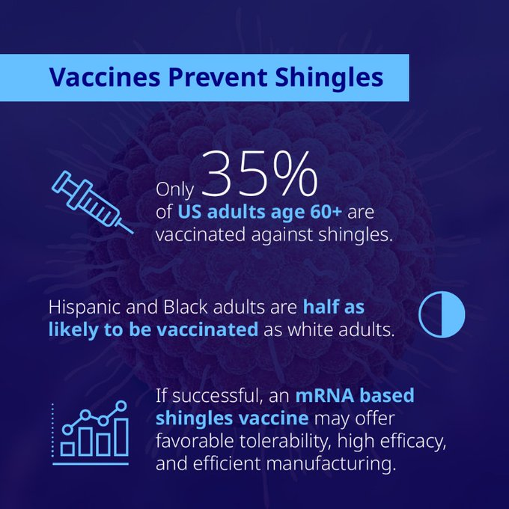
Click here to see the original tweet

